Playing the Pirate: Your Role on the Battlefield
First off, if you want to play a primary sieger, go home. The Pirate is not a sieger by design, though his multifaceted nature allows him to siege with great effectiveness when used well. He is a Hero killer, and a damn good one. He has the HP of a lesser tank and the damage output of a fearsome caster. With very little compensation you will have more than enough mana for anything you set out to do. He is very much like a Swiss army knife; flexibility is one of his main strengths.
Now, let us assume we are engaged in an expo war. It matters not whether we are at north or south, the Pirate's role remains the same: providing spawnie control and helping to pick off the enemy Heroes. "Spawnie control? But Mengde, the Pirate has no AoE!" Of course he doesn't, but he summons crabs. At level 5 and with their frenzy buff activated, they can help push back a wave of spawns or help your own wave push forward.
Now we come to the meat of your role: killing the Heroes. The Pirate has a very effective single-target nuke, and of course the Boat, but we will elaborate upon the Boat later. Jolly Roger Hoist, or JRH for short, is what you will be casting most. Three or four castings of JRH will make any caster flee and put a considerable dent in any tank's HP, with perhaps the exception of the Battlerager. When should you cast it? At the beginning of a fight, to bring down enemy HP, and at the end, to kill them. This should not be confused with getting the final hit in for greed. This is strategy and making sure that Hero doesn't get away. You open the battle with a JRH and then let your allies start nuking away. By the time the target starts to flee, JRH's short cooldown will have expired, and you will be free to kill them. And herein lies the genius of its design: you are teleported to the target's location when you cast it. "But isn't that bad? Doesn't that leave you vulnerable?" Yes, but the Pirate can take a few hits before going down because of his HP. Being towards the front lines due to a JRH cast means that when the Hero you targeted starts to flee, you will be in a position to finish him off. Do not underestimate the importance of this. You are oftentimes the last line of offense, so to speak, that a Hero has to cross in order to flee. If you can, do not let them cross it.
When your team is sieging, do not hesitate to pull out the crabs. Frenzy them, group them with you, and set all of you on a target building. If you can bring out 8 crabs and frenzy them all, building health will drop rather rapidly. If enemy Heroes show up, have your Pirate abandon the tower and engage them but keep your crabs on the target tower. This demonstrates just how flexible the Pirate is: he can continue to siege even as he deals with enemy Hero presence. Most other Heroes are incapable of this degree of versatility. Use this gift to your advantage. A last note on sieging: if your team is falling back, the building you are attacking has less than 300 or so HP, and you will not be able to kill it with normal abilities, don't hesitate to Boat it. The Boat can do a surprising amount of damage to buildings, especially at levels 2 and 3. It may provide that extra kick needed to bring down the cannon tower.
The Optimum Skill Build
Let us first review the skills of the Pirate.
Jolly Roger Hoist
Level 1: 100 damage to a single target
Level 2: 160 damage
Level 3: 220 damage
Level 4: 280 damage
Level 5: 340 damage
Summon Crustaceans
Level 1: 2 small crabs summoned
Level 2: 3 small crabs
Level 3: 3 medium crabs
Level 4: 4 medium crabs
Level 5: 4 large crabs
Quicksand Aura
Level 1: Decreases the attack rate of all affected enemy units by 6%
Level 2: 12%
Level 3: 18%
Level 4: 24%
Level 5: 30%
Spirit of the Adrian
Level 1: 800 damage in a large area, 180 second cooldown
Level 2: 1000 damage, 150 second cooldown
Level 3: 1200 damage, 120 second cooldown
Jolly Roger Hoist is an essential skill. You must have it to be a good Pirate. Similarly, Summon Crustaceans allows the Pirate to push in a lane and to have spawnie control. It too is vital. Spirit of the Adrian is obviously a very good skill. But what of Quicksand Aura? It is a useful skill, but it does not contribute at all to getting the Pirate kills or keeping him alive early on. Also, while Jolly Roger Hoist does help deal with any Heroes that might be contesting your lane, it does pitiful damage at level 1. The build I always use is this:
Level 1 - Summon Crustaceans (hereafter referred to as Crabs)
Level 2 - Jolly Roger Hoist (hereafter referred to as JRH)
Level 3 - JRH
Level 4 - Crabs
Level 5 - JRH
Level 6 - Spirit of the Adrian (hereafter referred to as Boat)
Level 7 - JRH
Level 8 - Crabs
Level 9 - JRH
Level 10 - Crabs
Level 11 - Boat
Level 12 - Crabs
Level 13 - Quicksand Aura (hereafter referred to as Quicksand)
Level 14 - Quicksand
Level 15 - Quicksand
Level 16 - Boat
Level 17 - Quicksand
Level 18 - Quicksand
Getting Crabs at level 1 (no puns please -_-) is a good way to make an initial lane push, as JRH is not really a good skill to use at level 1 and only starts dealing any kind of noticeable damage at level 2. Quicksand Aura is, as I stated before, eschewed in importance by all 3 other skills the Pirate possesses. You can try variations on this build if you like; I have found it the most solid and reliable. Now, I will elaborate on advanced strategies for use with each of these abilities.
How to Have Fun With JRH
JRH is a multi-purpose tool. It can be used to damage an opponent. It can be used to close the distance between the Pirate and the targeted opponent, possibly to set up a Boat (not recommended unless you can slow or stun the target). One of the least used but potentially very powerful uses is escape.
This happened to me in a game just today. I was in one of the middle lanes. My back was up against the middle area's wall. There were Allied spawns to my right and my crabs were to my left. I was effectively unable to move should danger strike. However, I was unconcerned. Why?
The game's Leto saw me in this somewhat precarious position and decided to have a little fun. He Bindu'd down from the center right behind me. Knowing that he was going to use his very damaging ultimate The Golden Path on me, I immediately triggered JRH on an enemy captain out of TGP's range. I escaped with my life and enough hit points to continue pushing the lane without worries.
When it comes down to it, JRH is an ability that moves you almost instantly from where you cast it to the position of the unit you targeted with it. Abuse this. Use it to the utmost extent. I have dodged Golden Paths, Winds, El Toro stomp moves, wakes, and Pluck Yews with this functionality. When you are in the air, you are invulnerable. Any area of effect damage intended to damage you is rendered void and the mana spent to send it at you is wasted. On top of this, if you can pick and choose your targets, you can also position yourself advantageously, whether in retreat or offense. Do not forget this. JRH is one of your greatest weapons.
Your Crabs and You
There are three roles in which the Summon Crustaceans skill is utilized: attack, retreat, and defense. There are three ways in which crabs can be used in attack, two ways in which they can be used in retreat, and two ways in which they can be used in defense.
When you are attacking, you are either sieging, pushing a lane, or trying to kill a Hero.
While sieging, your crabs should always be focused on a tower or other important building. Always. There is no excuse for having them dallying somewhere or other, doing something utterly useless like killing a Druid or trying to hurt the Battlerager. Your crabs are more damage to pour on the building you want destroyed.
When pushing a lane, your crabs are out, frenzied, and all focused on one target, preferably a Captain or a Druid. You are not using them to wail on Heroes here. The lane needs to be pushed with minimal damage to your friendly spawns so they can hit the towers harder, so you want to get rid of the hardest-hitting enemy spawns ASAP.
When trying to kill a Hero, the Crabs' damage is at best minimal against a moving target, so they are used to block the way. If you get an enemy Hero that can't blink naturally or doesn't have a blink dagger into a corner or half-surrounded by your or even their spawns, summon the Crabs! With any luck they will appear in encirclement formation and cut off the Hero's escape, making your job easier. Frenzy them and set them on the hero. It will die a lot faster when all your crabs can hit it along with you. If, however, you are coming in from behind or from an angle where the Hero you are targeting will not see you, then summon your Crabs and hide them somewhere. Attack the Hero, with your teammates if necessary. When the Hero starts to flee, bring out the Crabs and place them in a line directly in the fleeing Hero's path. They will block the Hero's way and make it have to go around, which makes catching up that much easier for you.
When retreating, Crabs are used in two ways. They can either be left behind to harass enemy Heroes or kill enemy spawns before they become a threat to your towers. You can also pull them back with you and cover your rear. Use them as you would if a Hero was fleeing and you needed to block its path. A Crab wall, especially at an expansion bridge, can buy the two or three seconds your casters need to escape.
While defending, utilize Crabs much as you would while attacking. If there is a caster channeling a spell in the back lines surrounded by his teammates, send your Crabs after him. He will be forced to break the channeling and run, or he will suffer enough damage that a JRH will finish him. When the enemy siege is broken, try to already have crabs behind them, making it harder for them to get away. It is much easier to siege an expansion if they do not have as many Heroes as you do.
One last aspect of the Crabs must be covered before we move on. In N, they have been given an Unsummon ability. "Mengde, why would I want to get rid of my crabs? I love them!" Aside from how perverted that statement is, it does have a point. Why get rid of your summons? Because it is XP denial. Enemy Heroes will not get XP from a Crab that is Unsummoned, whereas a crab that dies due to enemy damage will give them XP. It may not seem like much, but when you are summoning crabs over and over, do your best to micro them and Unsummon the ones that are receiving fire and are getting low. It is all for the greater good.
Boat Makes Friends! Section 1: How to Boat Properly
For those of you who are asking where your Quicksand Aura strategy section is, I advise you to kill yourselves and keep your stupidity from spreading through the human gene pool. Now, onto the fun!
Spirit of the Adrian, or Boat as it will be referred to hereafter, is the single most powerful instant-damage area of effect ability in the game bar none. It is a singularly powerful tool for killing Heroes. However, with power comes a price, and that price is that Boat is fiendishly difficult to hit with unless you know the proper technique. Why?
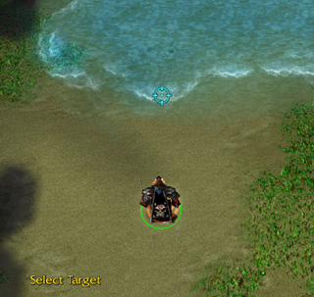
Here we see the Pirate aiming the boat in front of him to hit an imaginary target.
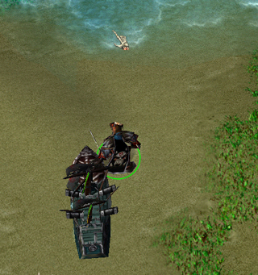
What do we realize? The Boat comes from behind the Pirate! But is this a problem? Let us see what happens when we try to Boat an enemy Hero using this method.
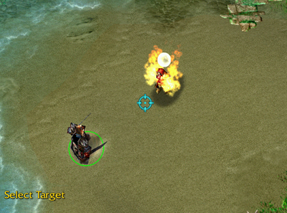
The Pirate has encountered an enemy Hero! He activates Boat and targets... (Note that for purposes of clarity both Heroes were under my control while the screenshots were taken.)
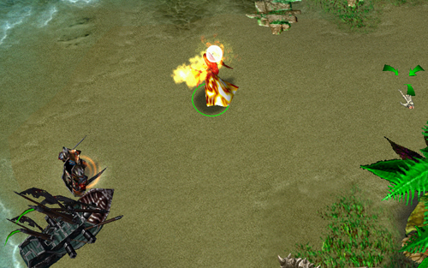
The Boat has again appeared behind the Pirate! Note that Jean has seen it coming and has been ordered to move out of the way. Fast forward three seconds, and the Boat will be gone and Jean will be unharmed by it. How do we prevent this?
I will illustrate the proper way to Boat an enemy here.
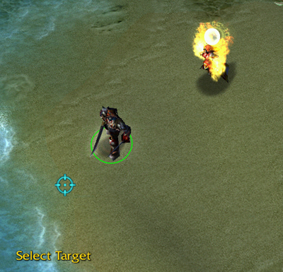
The Pirate is facing away from his enemy! And not only that, he is targeting in the direction opposite of where she is located! What madness, what foolishness!
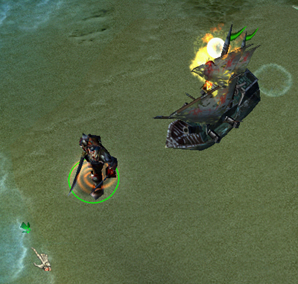
Or perhaps not, eh? Dramatic embellishment aside, this is called a Reverse Boat. It is the right and proper way to Boat an enemy Hero. If they do not see it coming, then there is no way for them to dodge it save for your own stupidity. It appears right on top of them and deals damage almost instantly.
However, in order to do this you must get close to your target. This can be accomplished with a JRH, to be sure, but a wise target will flee the scene as soon as he sees you activate the ability. A moving target is impossible to hit with a Boat without the use of...
Boat Makes Friends! Section 2: The Blink Dagger
Alternate Addendum Title: The Ninja Pirate
Blink dagger? Ninja Pirate? Repeat after me.
The Blink dagger is the Pirate's best friend.
A good, reliable Pirate who rakes in the Hero kills has a Dagger of Escape. Because it allows you to do so much more than escape, the name does it injustice, which is why most ToB veterans call it the Blink Dagger. It is the way you will close with your targets for a Reverse Boat and even be able to hit a moving target. The Dagger also allows you to close with a fleeing opponent that may have bypassed your Crabs (Musashi would Wind over them or Leto would Bindu past them) for a fatal JRH. It also lets you get inside those damn expansion walls and unleash your crabs on the tower without having to worry about pathing.
Do not be deterred by its 2200 gold cost. Ask your teammates to pool to you. 200 or so from each of them and you will have your Dagger in no time. However, certain items take precedence over the dagger early-game. These items will be discussed in the Item Builds section. Once you have your dagger, the sky is the limit.
First, the Blink Boat, or the Ninja Boat. This is not a complicated method, so it does not require screenshots to illustrate how to do it. You require a Dagger for this maneuver. The Hero's health should be at or below 600 (boat level 1), 750 (level 2), or 900 (level 3). Don't be afraid to do the math to see if a follow-up JRH will kill the Hero if the boat does not. If your results show that the Hero would survive, the maneuver will not be a certainty and it will in effect be a wasted Boat. What do you do then? Hurt the Hero. Bring it down to the point that a Boat + JRH or simply a Boat will kill it. If a Hero has a chance to run, then it has a chance to survive and waste your Ultimate.
Now, the Ninja Boat makes use of the Reverse Boat technique. What you do is Blink the Pirate right next to the target Hero. Try to position him so that when you cast the Reverse Boat, it will be coming in the direction the Hero would naturally flee in when he sees you appear in front of him. When you appear, IMMEDIATELY cast the Boat. It should appear on top of the Hero and, for lack of a more visceral term, ruin his shit. If he is still alive, a quick JRH will finish him if you did the math properly.
The Ninja Boat is not a guaranteed success. You may cast the Boat before you trigger the Dagger; the timing has to be that precise. However, when used by a skilled player, its success rate may be as high as 95%. With practice, you will be able to do it very easily. Also use the Dagger to place yourself in the midst of enemy Heroes for a multiboat. This kind of kill is very devastating to the enemy team, not to mention good for your image as a Pirate player.
Now, how do you hit a moving target? It is difficult, but I will show you.
Boat Makes Friends! Section 3: Don't Run, We Are Your Friends
Ever been in that situation where half the Allies are dead, that damn caster is running, and they have enough health to make it back to base no matter how many JRHs you pour on them? Fear not! The Boat can hit a moving target with assistance from the Blink dagger. Observe.
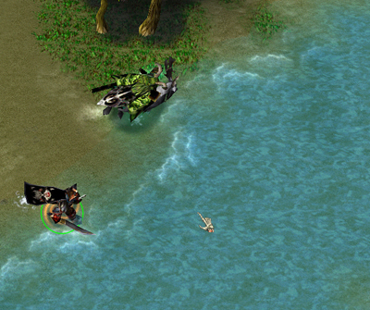
Oh Malfurion, you cause us so much trouble. No way you're getting back to base.
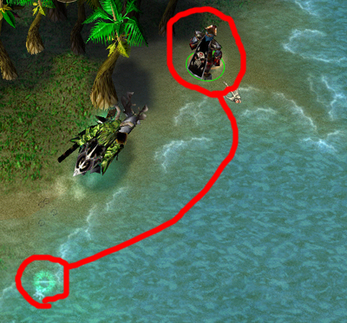
When pursuing a moving target, blink DIRECTLY IN FRONT OF THEM. If you blink to the side or behind them then this WILL NOT WORK and you should conserve your Boat for another time. I have outlined where my Pirate blinked from and where he appeared in red, because the effect of the Blink dagger is hard to see.
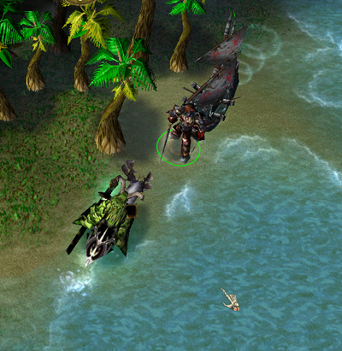
IMMEDIATELY after blinking in front of the target, DO NOT REVERSE BOAT, but instead TARGET THE ENEMY WITH THE BOAT. If you reverse boat, the enemy will outrun the boat and probably laugh his face off at you. Instead, have the boat come from behind you. Unless the enemy has very quick reflexes, he will crash right into the boat and most likely die. This is the only time EVER that you should aim the boat at the target instead of opposite where the target is.
Do note that this is NOT a guaranteed kill. It is tricky at best, and a miserable waste of a Boat at worst. I miss on these one out of five times. For me, that is a very bad ratio indeed. Do not be surprised if you do not get the hang of this right off the bat; this is a very advanced Boating technique that should not be attempted by newcomers to the Pirate.
Boat Makes Friends! Section 4: Psychological Effects
The Boat is a fearsome weapon. Once you hit level 6, you are almost guaranteed to see any enemy player shy away from you when you start running towards them. I've had El Toro players at full health run from me at level 6 because they vastly overestimated the damage I could deal with Boat. If you are leveling in a lane and get an opposing player that is afraid of dying, exploit this to the utmost. Do not push the lane yourself, but instead have your crabs do it for you. Run after the player. JRH him. Have your Pirate turn around as if he was going to reverse boat and watch the player flee.
In emergency situations, the threat of a Boat can be just as deadly as a real one. Is your Boat not cooled down? Are the Allies closing in on your wounded caster? Run or Blink up to them suddenly and turn around as if you are about to boat. Watch them scatter and leave your caster be. Then get the hell out of there, as they are going to be very angry at your for denying them their kill. This may not always work. Some people are singleminded enough that they will ignore the possibility of death and continue after your caster. Try to gague their reaction to your feints before attempting to do anything noteworthy with one.
Players often get very angry when Boated. If they start railing at you in all chat, you have two courses: ignore them, which may cool them down or make them angrier, or goad them, saying it is yours to abuse. That will probably anger them to the point that they will come after you exclusively in combat. If you can anger Musashi or Leto this way, it is one less threat to your precious casters. Remember: you have the HP of a lesser tank. You can take a few hits before having to heal or flee.
Item Builds for the Pirate
The good, all-purpose Pirate build utilizes three key items: the Pendant of Mana (1000g cost), Boots of Sprinting (1400g cost), and the Dagger of Escape (2200g cost), coming to a grand total of 4600 gold. If you are strapped for cash, you can eschew the Pendant, bringing it down to 3600g total. If you are desperately dry, buy Boots of Speed (400g) rather than Boots of Sprinting, bringing it down to 2600. However, even the most bare-bones Pirate gets a blink dagger. I personally have never been so poor that I needed to not buy a Pendant or Boots of Sprinting.
The Pendant is good because it supplements the Pirate's slightly poor Mana early game. With all his spells costing at least 100 mana, and considering how often you should be casting these spells, he is mana-intensive at best.
Boots of Sprinting are excellent because they are good for rapid transit to an expansion under siege, to help an allied Hero, to catch up to a fleeing enemy Hero if your Dagger is not cooled down, or to escape. They also provide a good movement boost, and I believe their base boost is higher than that of Boots of Speed (do not quote me on that, I am not sure).
The Dagger is vital, and its uses have already been covered in this guide.
If you are filthy rich, pool to a teammate for towers or buy a worker and build your own! However, if you are not required to pool for towers or do not need to build your own, then good high-level items are Frost Wyrm Skull Shields and Lava Forged Shields. Both of these expensive items (Frosties are 3500g, Lavas are 2200g (I think)) serve to increase the Pirate's survivability level in battle. Lavas are especially useful, since at level 18 the Pirate only has 10 armor, which is actually less than some Allied caster heroes possess at an equivalent level (Malfurion for example has 11 armor at level 18 ).
Before I wrap up the guide, permit to lecture you upon the dangers of consumable items. At the start of the game, I buy myself a mana potion and then a Death Wizard to ferry me items. That is 250 gold that is not devoted to getting my Pendant, Boots of Sprinting, and my Dagger. That, also, is usually all that is not devoted to the stated cause. I do not buy health pots or extra mana pots. I do not buy anti-magic potions or doubleshot expressos. Why? Because for every consumable you buy, you are that much farther away from your permanent items.
Lovers of potions and AMS will object. They will say that these items increase your chance to survive on the battlefield. In my view, there are two teams I could fight. I could be facing a team that poses no significant threat, meaning that they cannot kill me unless I am not paying attention. If I am paying attention, then they will deal little damage to me, negligble enough that consumables are unnecessary. Then there is the team that possesses some degree of skill, and can probably kill me whether I have consumables or not. It is better not to spend the gold on consumables and suffer the gold death penalty then to go broke on consumables and then suffer the gold death penalty on top of it.
Final Summary
And we at last come to the end of this gargantuan guide. I can say it has been a good time writing and preparing it for public scrutiny. Let me part with a few words of encouragement to you Pirate players. Do not give up on learning the Boating techniques. I struggled for a while with Ninja boating and hitting moving targets before it clicked and I was able to do it relatively easily. And do not let players who use other heroes get you down. "You contribute immobilization or healing, what good are you?" You contribute more damage against a single target than any other Undead Hero can boast. You have more versatility than any other Hero can achieve. You can kill Heroes, siege to a good extent, push lanes, defend, and make the entire enemy team scatter in terror of the Boat.

